Operating System Installation

Operating System, Functions and Characteristics

Operating System (OS) is a layer of software which is used to manage computer resources. It also provides an interface, so that users can utilize computer resources. It configures and manages hardware to connect the components and the applications.

It allows the user to communicate with the hardware to send their command (input) and received the intended result (output).

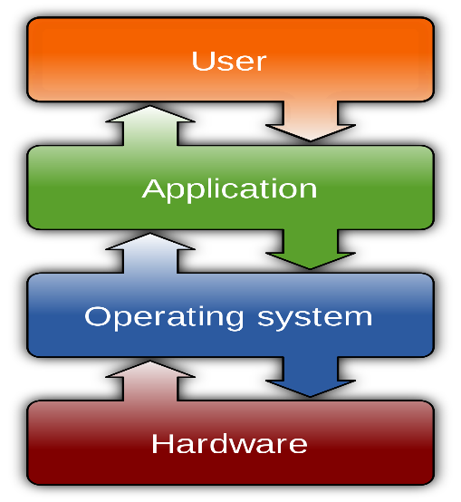

Functions of Operating System

1. Memory Management

One of the main functions of OS is to manage the primary and secondary memory. All the memory devices such as hard disk, pen drive etc. are managed by OS. Memory management keeps an eye on each and every memory location, in any case either it is allocated, or it is not allocated (free). Memory allocation to the processes is also decided and checked by Operating System. It decides and checks which process will obtain memory and at what time.

2. Device Management

An OS with help of their respective drivers manages device communication.

• It Keep a track of all devices. This task is performed by I/O controller.

• It decides which process will get the device when and for how long.

• It allocates and de-allocates the device efficiently.

3. Processor Management

In a multi-programming environment, it is OS who decides which process will get the processor when and for how long. This task is called Process Scheduling.

• It keeps a track of processor tasking and checks the status of process. Traffic controller performs this task.

• It allocates the processor and de-allocates processor when a process is complete and not required.

4. File Management

In a file system, generally directories are organized for usage and easy navigation.

Following activities are performed by an OS under file management:

• keeps a track of location, information, status etc. This collective is known as File System.

• decides who will get the resources.

• allocates and de-allocates the resources.

5. Controls System Performance

Operating System records delays between a request and response of the system. It monitors the overall system health.

6. Security

An OS by using password and other similar techniques prevents and checks unauthorized users to access the data and program.

7. Error Detection

By using various error detecting aids an operating system helps in prevention of errors.

8. Coordination among Software and Users

It Coordinates and assigns compilers, assemblers, interpreters, and other software to users.

9. Job accounting

It keeps a track of resources and jobs used by different users all the time.